Secure Information Exchange Program Simulation
Create a simulation program that exchanges information from user A to user B.
The program will use Diffie-Hellman to exchange key from user A to user B and will use AES-128 as encryption.
The prime number p=199 and the generator g=127 will be used for the Diffie-Hellman.
If a message is greater than 128 bits, it will be chunked into 128bit sub-messages. If a sub-message is less than 128 bits, it will be padded with an 8-bit data ‘@’ or ‘01000000’
Use the ASCII table below.
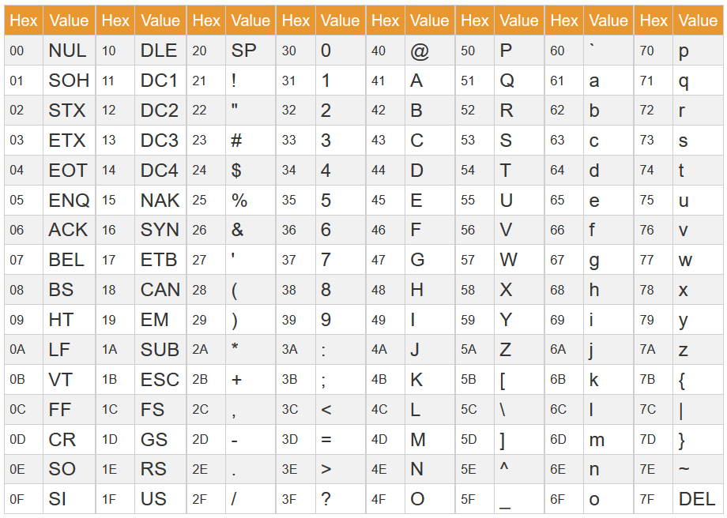
The Private Keys will be in a form of decimal equivalent of the ASCII value. For example, Private Key for User A is 57, 57 is 00111001 in Binary which is 39 in Hex and has an equivalent character of ‘9’. Using prime and generator:
gª mod p = 127⁵⁷ mod 199 = 17
Thus, Public Value for User A will be 17.
If User B’s Private Key is 167, the Public Value is 75:
g^{b} mod p = 127¹⁶⁷ mod 199 = 75
Computing for the Shared Key:
75⁵⁷ mod 199 = 109 ; 17¹⁶⁷ mod 199 = 109
The Key used in AES-128 is 128-bit key. The Shared Key must be transformed into 128-bit key. The transformation will be:
- The Shared Key will be represented as ASCII Characters.
  - 109 is ‘1’, ‘0’, ‘9’ which is 31 30 39 in Hex
  - 57 is ‘5’,’7’ which is 35 37 in Hex
- If single character, the 128-bit key will be as series of the single character and character ‘C’ alternating.
  - Example: Shared Key is 1, Key will be 1C1C1C1C1C1C1C1C
- If two characters, the 128-bit key will be a series of the 2 characters and characters ‘DD’ alternating.
  - Example: Shared Key is 58, Key will be 58DD58DD58DD58DD
- If three characters, the 128-bit key will be a series of the 3 characters and a character ‘F’ as separator.
  - Example: Shared Key is 109, Key will be 109F109F109F109F109F

Given a MESSAGE: “The Mandalorian Must Always Recite, This is The Way!”
The message has 52 Characters. AES encrypts a 128-block. Each character is an 8-bit data. So we need to create sub-messages of the original message that contains 16 characters each.
Sub-message1: “The Mandalorian “ - [54 68 65 20 4D 61 6E 64 61 6C 6F 72 69 61 6E 20]
Sub-message2: “Must Always Reci”
Sub-message3: “te, This is The “
Sub-message4: “Way!@@@@@@@@@@@@”
Notice that Sub-message4 is padded with the character ‘@’ to create the 128-bit block of data.

Each Sub-message will be encrypted separately. Each encrypted sub-message will be concatenated to form a big block of Encrypted message and will be sent to the Receiver. The Receiver will create sub-messages of the encrypted messages and decrypts each sub-message separately. The decrypted sub-messages will be concatenated to form the Original Message

